Seamab school

Secondary Teacher(s) wanted - Mathematics, Science and Physical Education (Full time or part time)

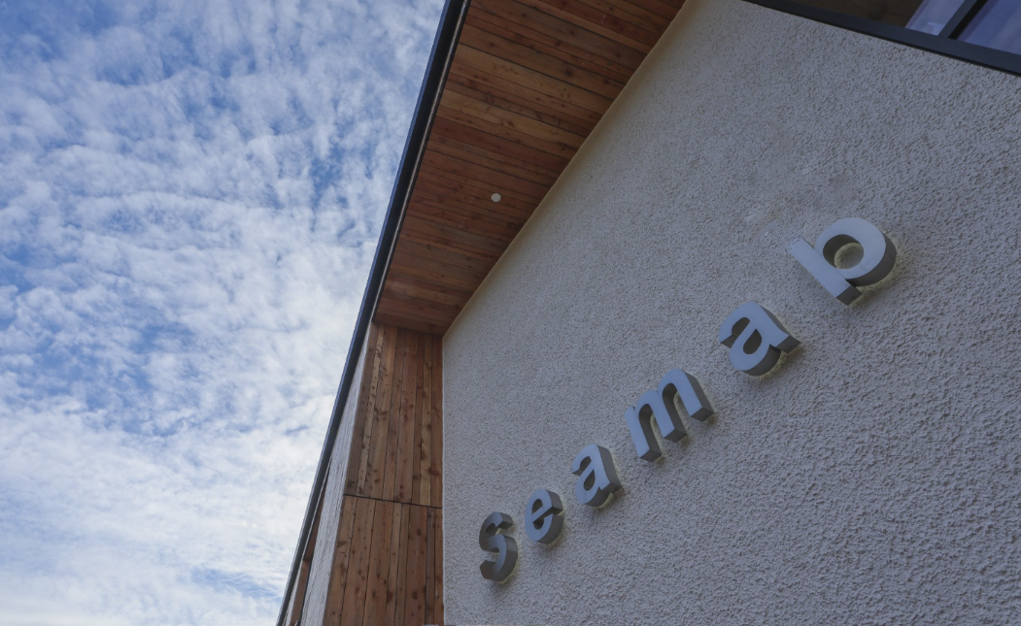

This is an exciting time to consider joining Seamab school. We moved into a new purpose-built school in February 2026 and are now developing our school to expand our secondary curriculum. We are keen to speak with suitably qualified teachers in Mathematics, Science and Physical Education.

We are a school – primary and secondary – and we are a charity where we educate our children and young people, but we also care for many of our students in our residential accommodation. Our pupils are placed with us by local authorities across Scotland, and our children may have experienced a range of adverse childhood experiences. Their needs are complex, and we work in a way that is trauma informed, carefully considering their journeys educationally and socially, prior to their coming to Seamab.

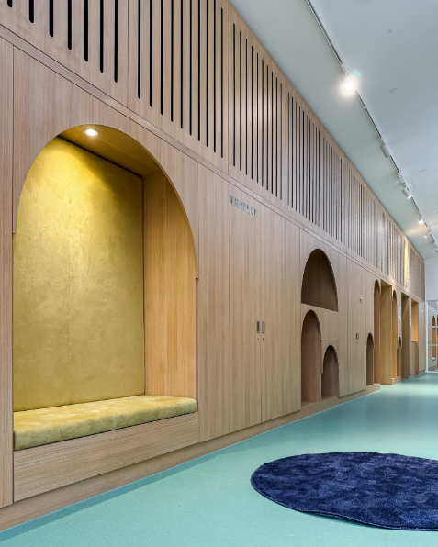
Our school is small with up to 25 pupils, the majority living with us residentially, and our age group caters for ages 5 through to 18. Our class sizes are small, delivering a Curriculum for Excellence tailored to meet individual pupil needs. The journeys that our young people have experienced demand that we are resilient, consistent and persistent in delivering their learning at Seamab. The environment can be challenging but at Seamab we prepare and train our staff so that they feel supported and equipped to help prepare our pupils for life. The rewards are incredible at Seamab. It is an opportunity to support children who have often lost faith in education and in their own ability to learn and to be able to change that trajectory to a much more positive outcome. We believe in untapping the potential that lies within all children and young people. Although we follow the national curriculum, Curriculum for Excellence, we teach to the needs of the pupils and meet them where they are in their learning ability.

You will be confident to deliver Broad General Education, together with national qualifications, awards and NPAs (Qualification Scotland). You will plan, track and monitor pupils progress and differentiate learning activities to meet pupils needs, meeting the pupils where they are at in thier learning.

You will have a genuine interest in working within a trauma informed setting demonstrate a high level of flexibility and a willingness to ensure pupils’ needs are met at all times.

Job Description:
Secondary Teacher(s) wanted

In subjects – Mathematics, Science and Physical Education (F/T or P/T) - we are open to dialogue on a range of contacted hours for each role

Responsible to: The Head of Education

Salary Scale: £43,383 to £54,453 per annum (pro-rata for part-time)

Working Hours: 35 hours per week full-time (or part-time). Fixed term for 2 years initially.

Location: The Teacher will mainly be located at Seamab School but may also be located on the residential campus. They may also be responsible for trips and activities which take place away from Seamab.

Purpose of Post:

To plan, manage and deliver Curriculum for Excellence through high quality learning and teaching in specialist subjects, meeting the needs of vulnerable children with complex needs while also supporting all other aspects of school life. To contribute to effective interdisciplinary learning and the implementation of the 24-hour curriculum working in partnership with colleagues across services – education support workers, therapy team, care workers. To engage positively with children and young people using creative and innovative approaches to fully engage them in their learning. The teacher will understand and be committed to delivering the Seamab vision and philosophy of learning and caring.

Duties and Responsibilities:

The Teacher has the lead responsibility for providing appropriate learning and teaching for individual children; they will regularly assess and review the progress of children and plan for their attainment and achievement. To help achieve this, they will plan and guide the work of education support workers and care workers in the education team. The Teacher will participate in regular child's planning meetings with the care team and work directly with care team managers and staff. They will work collegiately with the education team to develop a bespoke curriculum and develop opportunities that will enable the pupils to thrive and prepare for positive destinations. They will promote the principles of the curriculum at Seamab, working to provide active and outdoor learning experiences for children.

Duties and responsibilities in learning and teaching:

- Plan learning and programs of subject-related course work and teach young people in group and individual settings, carry out assessments and record and report on the progress and achievements.
- Undertake development of the curriculum in line with the principles of Curriculum for Excellence, including 24-hour curriculum development and achievement awards.
- Assume responsibility for continuing professional development and contribute to the professional development of colleagues.
- Actively participate in the process of professional supervision, which focuses on support, learning and accountability.
- Advise and guide young people on issues relating to their learning and development in line with the policies and procedures of the organisation.
- Act as key teacher to a small group of young people, working with their key workers as appropriate.
- Present young people for, and participate in, the conduct of national examinations, national and internal testing procedures and organisational practices in relation to the assessment of young people.
- Contribute to the monitoring and evaluation of the curriculum.
- Contribute to the evaluation and development of teaching materials and other resources.
- Ensure that appropriate procedures are observed in relation to child protection and the health and safety of young people and colleagues.
- Report and discuss young peoples’ progress with their parents/carers, colleagues and other agencies who have a statutory function in relation to the care of young people, as appropriate.
- Attend LAC reviews, Child’s Plan Development Meetings and other meetings, as required, contributing to the Getting It Right for Every Child approach.

Duties and responsibilities in relation to continuing professional development

- Be aware of and work within the Seamab guidance on professional update for teachers, meeting GTCS requirements.
- Prepare for and participate in regular meetings and reviews to reflect on and discuss professional learning and development.
- Attend and contribute to in-service days with the education team.
- Attend external training and share this with the wider team.

Duties and responsibilities in relation to the wider Seamab team

- Understand and apply in practice Seamab's vision, values and philosophy of learning and caring.
- Contribute to and support effective communication.
- Regularly provide information to the care team and external professionals on the progress of children.
- Maintain robust records of children and their progress.
- Contribute to recording children's daily experiences, and any incidents and accidents.
- Support and advise the multi-disciplinary team on achieving positive educational outcomes.
- Promote creative learning experiences across Seamab.

You will have the professional autonomy to adapt your practice, supported by experienced colleagues who understand the complexities and rewards of this setting.

Other Duties and Responsibilities

To undertake any other duties which may reasonably be regarded as within the nature of the duties and responsibilities / grade of the post as defined.

PERSON SPECIFICATION

Personal Competencies
- Physically and mentally resilient.
- Highly motivated with demonstrated commitment and enthusiasm to improving outcomes for young people.
- Mature, trustworthy and reliable.
- Excellent interpersonal skills.
- Excellent communication and presentation skills.
- Ability to work as a team and to act on own initiative.
- Ability to work under pressure.
- Flexible and creative approach.
- Conflict/crisis resolution skills.
- Strong commitment to working with young people experiencing social, emotional and behavioural challenges.

Professional Competencies
- Demonstrated ability to engage positively and effectively with young people.
- Understanding of current education practices and theory.
- Understanding of therapeutic behaviour management techniques.
- Sound working knowledge in specialised subject area and BGE.
- Highly professional attitude and presentation.
- Demonstrated ability to reflect on and improve own practice.
- Commitment to self-evaluation and improvement.
- Experience in additional support needs is desirable but not essential.

Qualifications and Experience
- A professional teaching qualification.
- Registered with the General Teaching Council for Scotland.
- A minimum of 1 year teaching experience.

References and Standard checks
- Professional references, including previous and current employers, verifying personal/professional competencies.
- Disclosure Scotland PVG Scheme member for the Children’s workforce.

