EMPLOYEE BENEFITS

Working week Our full-time working week is 37.5 hours per week and applications for flexible working are considered. For Teachers, SNCT conditions apply.

Healthshield Seamab provides employees with a Level 1 health cash plan. This includes access to mywellness online tools and information, 24/7 counselling and support helpline, face to face counselling, mindfulness app and online health assessments.

Holidays The holiday year runs from 1st April to 31st March. Entitlement for new employees working full-time is 255 hours per annum, rising to 292.5 hours after 5 years’ continuous service. Pro rata for part-time and term-time working patterns.

Induction New employees are provided an induction plan, to support them joining our teams. We work over three locations, the Seamab School and Seamab Care Campus. In addition, the new Care Home at Linlithgow.

Ongoing Learning Employees have access to the Charity Learning Consortium and additional opportunities are provided, related to development needs.

Pension Employees are eligible to join the Seamab Pension Scheme which is a standard ‘salary sacrifice’ scheme, provided by Legal & General (5.5% employee, 11% employer).

Probationary Period New employees are employed on a probationary period of six months.
Salaries Salaries are paid by bank transfer on the 28th of each month.

Seamab Extra Mile Award We recognise and celebrate those moments when employees go that extra mile, above and beyond to make a difference.

Sick Pay On satisfactory completion of the probationary period the Organisational Sick Pay is as follows:

Service at Commencement of Absence from Duty | Full Salary for a period of | Half Salary for a period of
Less than 26 weeks | SSP only | SSP only
26 weeks but less than 1 year | 2 weeks | 2 weeks
1 year but less than 2 years | 5 weeks | 5 weeks
2 years but less than 3 years | 9 weeks | 9 weeks
3 years but less than 5 years | 11 weeks | 11 weeks
5 years or more | 13 weeks | 13 weeks

Seamab Group Life Assurance AIG Insurance provides death in service support, 4 times annual salary. Excludes casual employees who have not been paid in a period of 6 months or more and does not cover between periods of engagement.

Our Mission

To provide a loving and caring school and home environment for children and young people up to the age of 18 with challenging or complex needs. We will build relationships where they learn to trust and be trusted, feel safe, and have fun. To educate our children in ways that work for them as individuals, including through the outdoors, play and adventures. To teach them crucial life skills in a stimulating and nurturing environment where every adult is focused on their happiness and wellbeing. To enable them to grow up to be confident, contented and valued members of society. Their voices will be listened to and be at the heart of everything we do.

Our Values

- Caring and nurturing – we provide a safe, caring, and nurturing environment where relationships are key to all we do. We will continue to foster a positive environment with a focus on health and wellbeing.

- Courageous - we accept the unique challenges of working with children with extremely complex backgrounds and needs. We will be resolute, brave and determined in doing whatever it takes to provide a loving, safe and fun environment.
- Resilience - we will build resilience within the young people we support so they can have happy, healthy and fulfilling lives. We will ensure staff are supported so they have the capacity, capability and creativity to meet the needs of the children, whatever those may be.

- Ambitious - we are determined to help children and young people achieve their full potential, putting their individual needs at the heart of everything we do.
- Excellence - we will seek to innovate and strive for excellence in all that we do.



In the past, Seamab had difficulty connecting emotionally with potential donors and the local community. For privacy reasons we can’t show the children’s faces in promotional material to tell their specific stories which in turn made it difficult to engage with the outside world. The Sea Changers are a set of characters who give Seamab an endearing voice to tell their story.

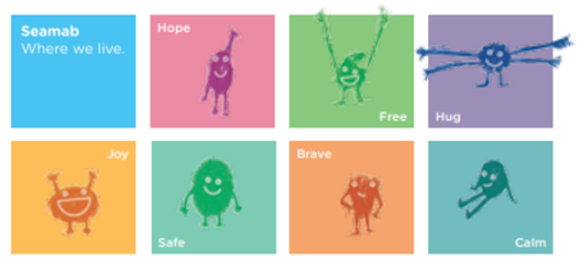

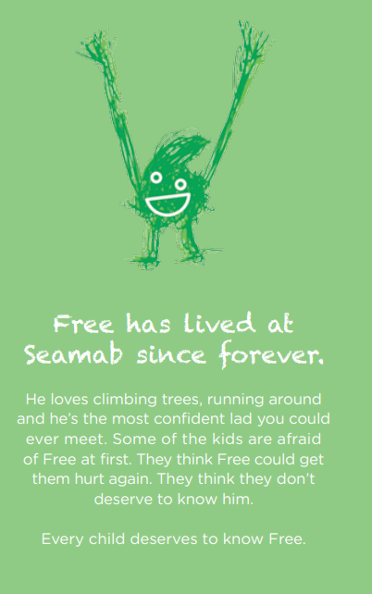

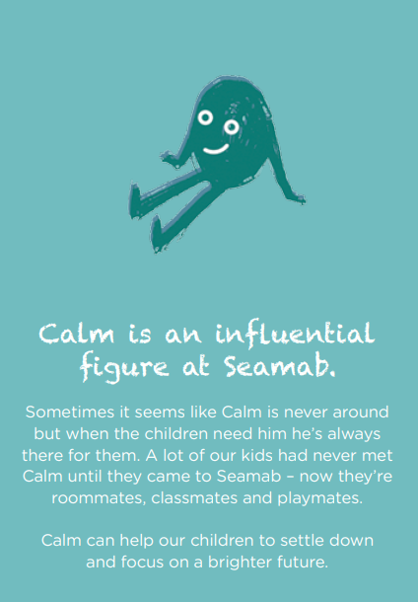

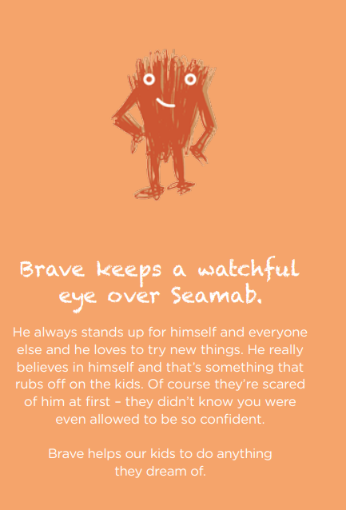

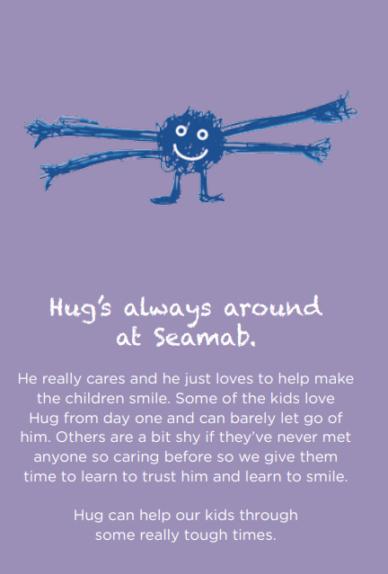



Joy has always lived at Seamab. When some kids arrive here they can’t seem to find her. They’ve never met her before and they don’t really know what she looks like. When they are introduced to her they can be hostile at first – she is a stranger after all. Given enough time, care and attention, every one of our kids can get to know Joy.



Hope is never lost at Seamab. She’s lived here for a long time and she knows the place like the back of her hand. She picks the kids up when they fall and she’s always showing them how good tomorrow could be. When the world seems really dark, Hope gives the kids a loan of her torch. Without Hope our kids wouldn’t stand a chance.

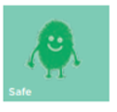

Safe lives happily at Seamab. She’s warm and friendly and a great listener. She tucks the kids in at night and stays by their sides when they’re afraid. Some kids like to hold Safe’s hand, some like to hide behind her and some are just so happy to know she’s there for them. Safe should be there for every child.


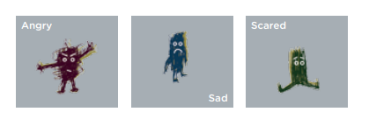

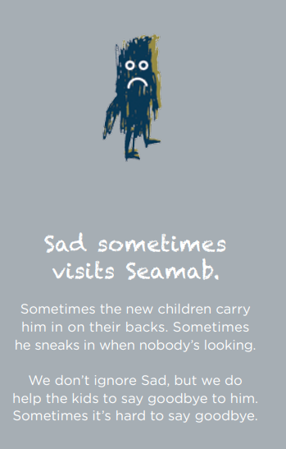

Children and staff developed Sea Changers with StudioLR.

